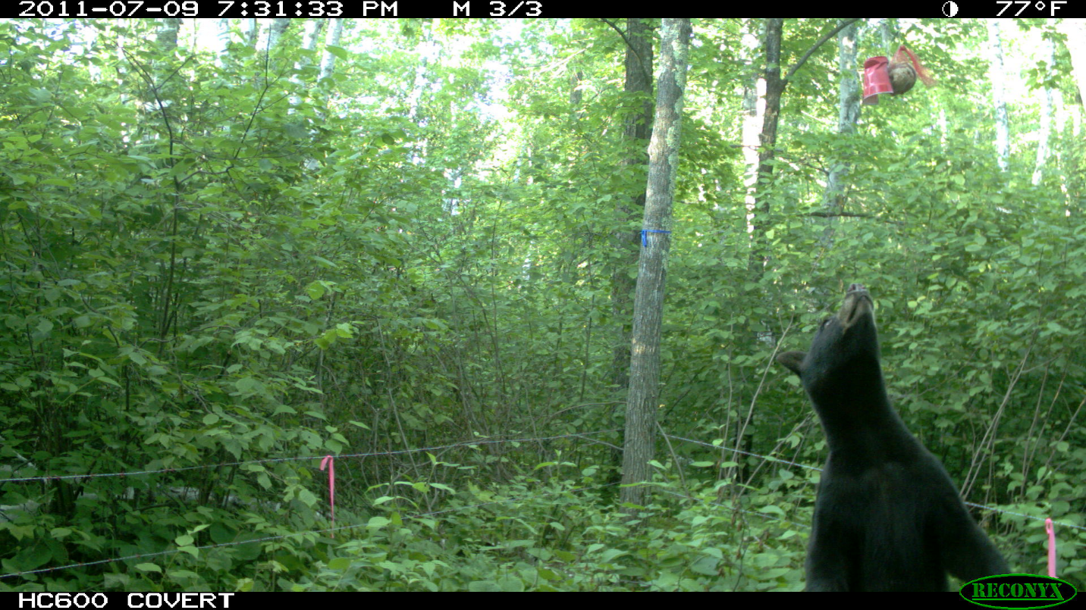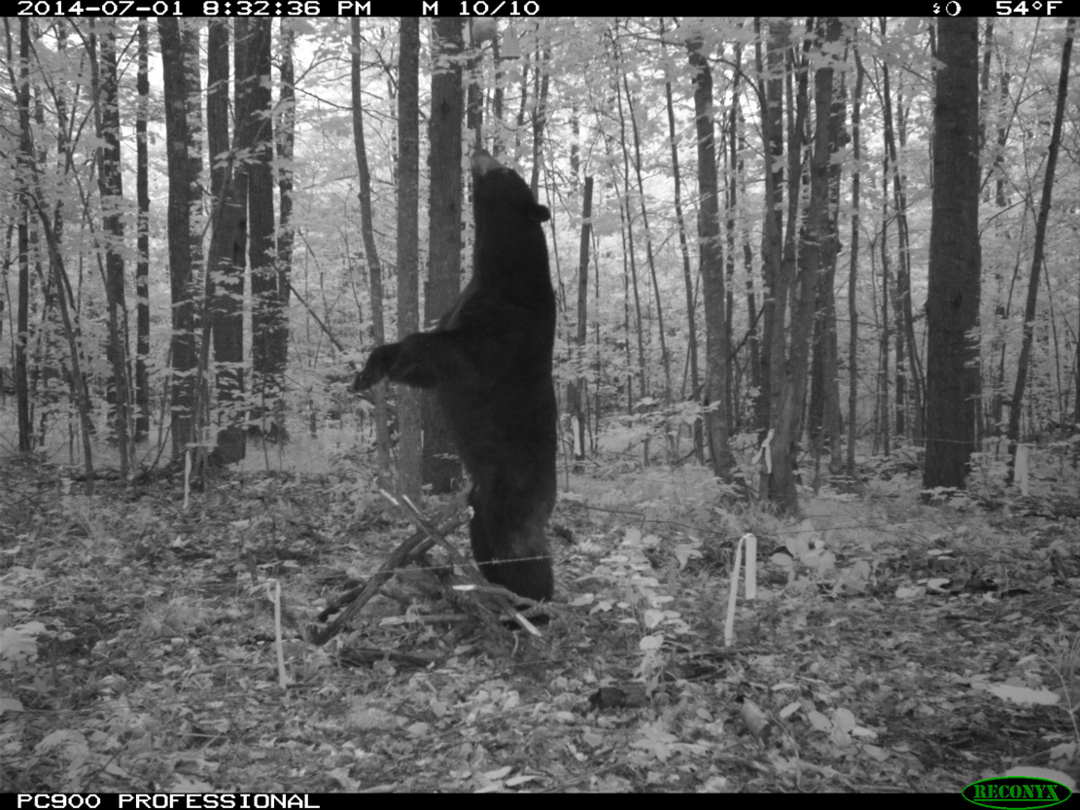Figure X. Camera traps set at some hair snare sites indicated that individual bears repeatedly visited, even though they received no food rewards. The bait and scent (in red cup) were suspended above their reach, but they continued to make concerted efforts to retrieve it. In so doing, they left multiple hair samples at these sites, which for SECR analyses are all considered redundant.